LAB 5

Q1.)

(a) What is the destination MAC address of an ARP Request packet?
Destination MAC Address : ff:ff:ff:ff:ff:ff

(b) What are the different Type Field values in the Ethernet headers that you observed?
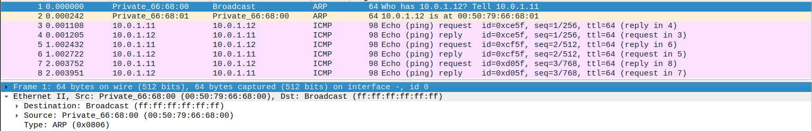
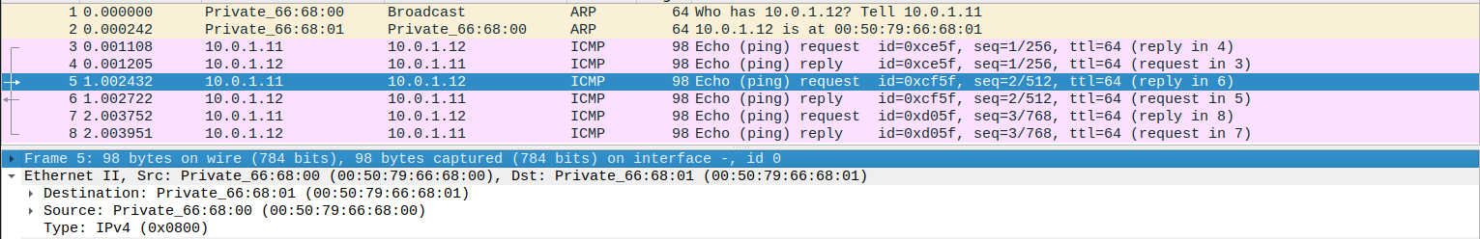
ARP and IPV4

(c) Use the captured data to analyze the process in which ARP acquires the MAC address for IP address 10.0.1.12
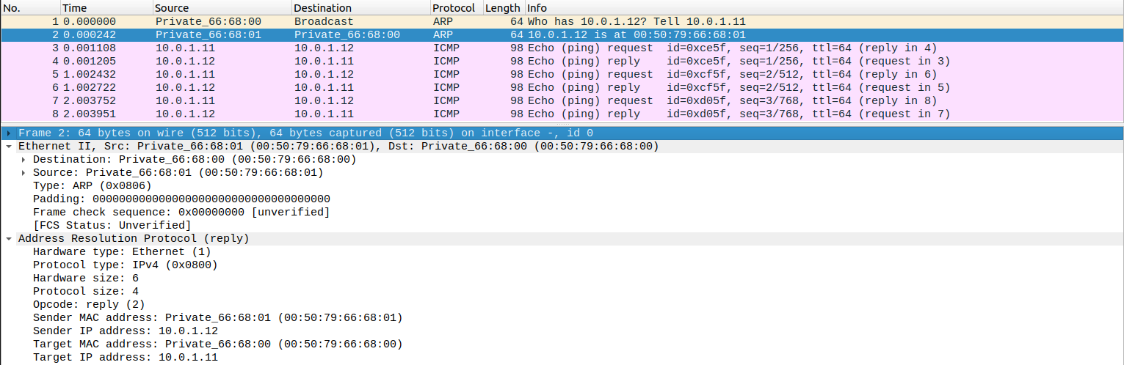
When we try to ping , it will send an ARP broadcast request to check who has the IP Address 10.0.1.12
The PC having the given IP Address sends an ARP Reply to the Requested PC along with it’s MAC Address

Q2)

We can’t assign duplicate ip addresses in GNS3.

(a) Explain how the ping packets were issued by the hosts with duplicate addresses.

As we can’t assign duplicate ip addresses , we set the ip of it as specified in the question 1 to move forward to next questions.

(b) Did the ping command result in error messages?

It didn’t result in any error messages because we are pinging the PC itself.

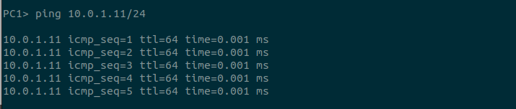

(c) How can duplicate IP addresses be used to compromise the data security?

Duplicate IP Address leads to ARP Spoofing
Attacker pretends to be the original ip and can steal or change the the data received to him , which is a security risk.
To prevent this, every PC should have a unique ip address and have security tools to prevent these attacks.

Q3)
(a) Use your output data and ping results to explain what happened in each of the ping commands.
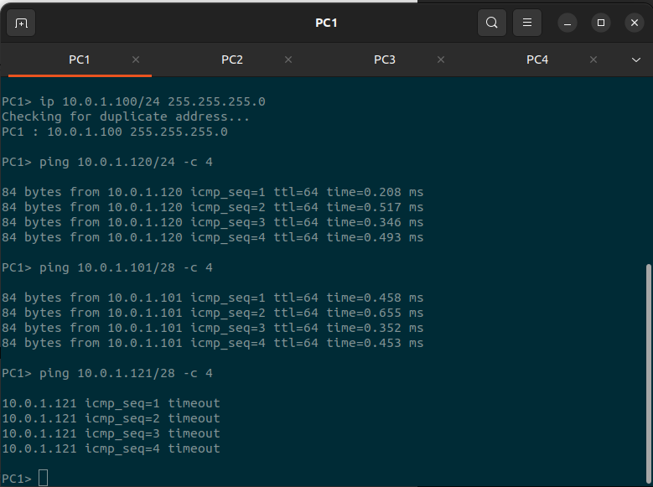
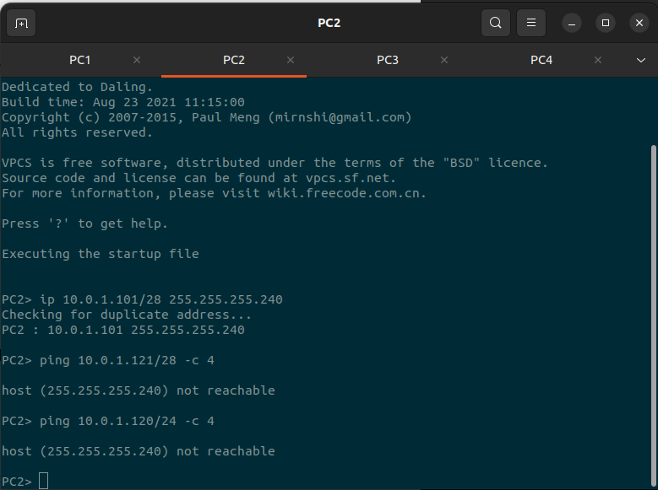
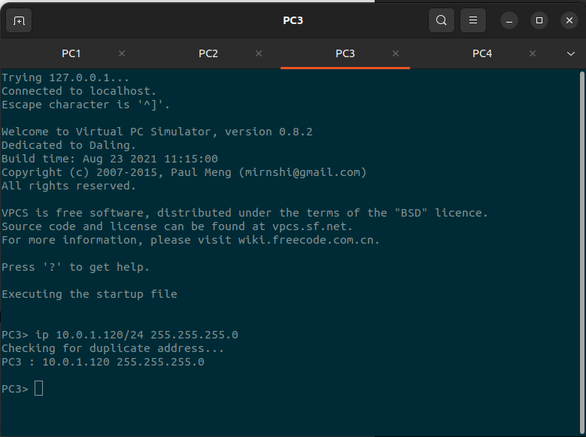
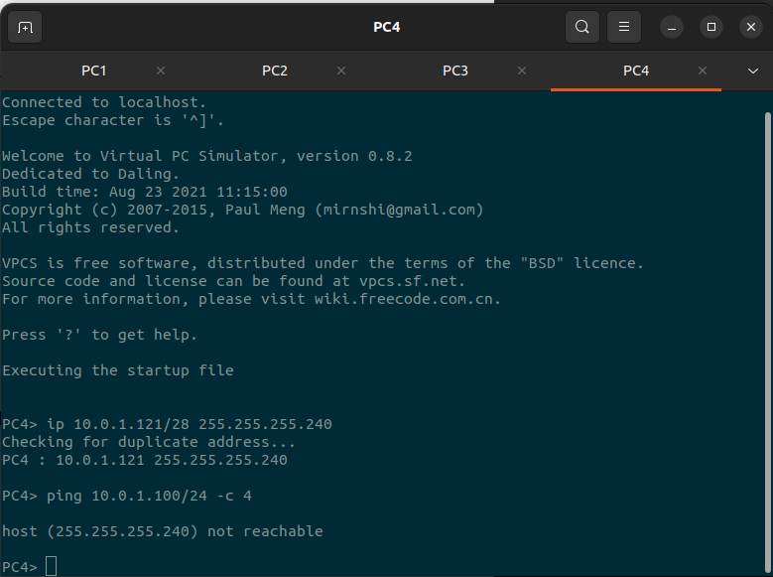

i. **From PC1 ping PC3**:
This ping operation was successful. PC1 and PC3 were able to communicate because they are on the same network with the same network mask, so they can directly communicate.

ii. **From PC1 ping PC2**:
This ping operation was successful, but it initially experienced ARP requests for an unusual IP address, which might be due to a configuration issue or misinterpretation of network settings. However, once PC2 replied, the communication succeeded.

iii. **From PC1 ping PC4**:
This ping operation was unsuccessful (timeout). PC1 tried to ping PC4, but PC4 did not respond to the ICMP Echo requests.

iv. **From PC4 ping PC1**:
This ping operation was unsuccessful as well (unreacheable). PC4 attempted to ping PC1, but PC1 did not respond to the ICMP Echo requests.

v. **From PC2 ping PC4**:
This ping operation was unsuccessful (timeout). PC2 tried to ping PC4, but PC4 did not respond to the ICMP Echo requests.

vi. **From PC2 ping PC3**:
This ping operation was also unsuccessful (timeout). PC2 attempted to ping PC3, but there were no responses.

(b) Which ping operations were successful and which were unsuccessful Why?

Some ping operations were successful (i and ii), while the others were unsuccessful (iii, iv, v, and vi). Unsuccessful pings could be due to misconfigurations, network issues, or devices not responding to ICMP Echo requests.

NAYAKANTI SAI MIHIRNATH - 210905368

